Mini Project

# Task 1

## Part 1 Combing Teams and States

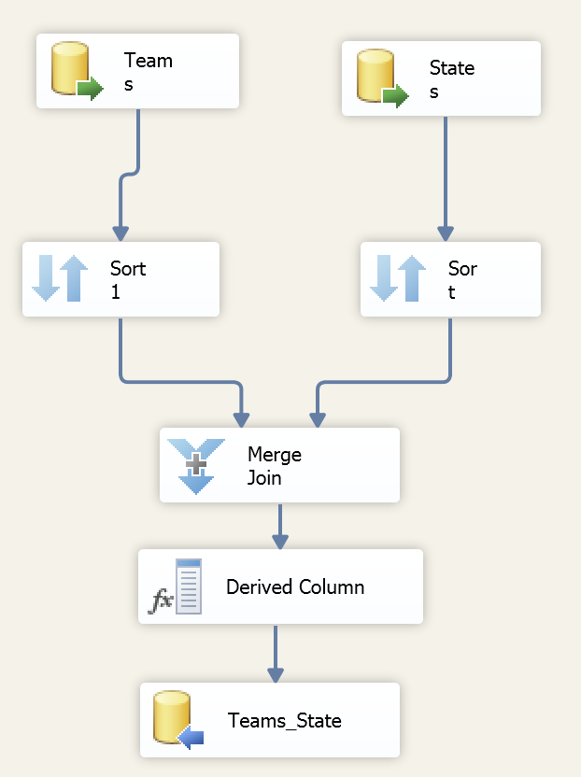 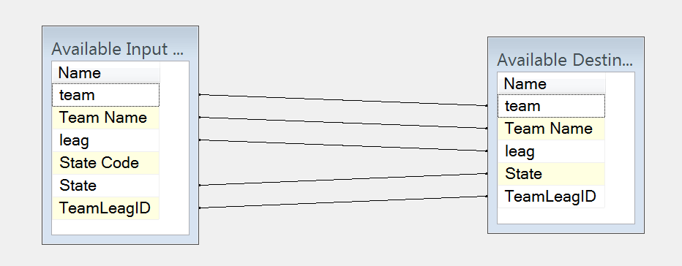

The ETL is data extraction, transformation and loading. In this task, data are extract form Teams and States.

But the [States] has some duplicated record of state which should be deleted.

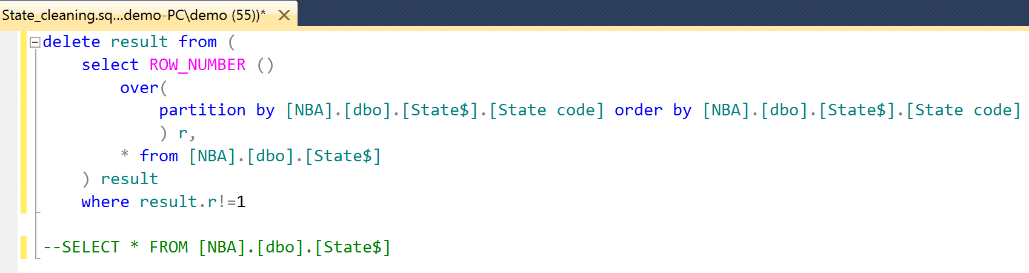

Then, select “State Code” as joint key to join two table. Finally, execute the package to load the table [*Teams_State*] to data warehouse.

Then, the new attributes set is {team, Team Name, leag, State Code, State} in the [*Teams_State]* relationship. And there are ‘State Code->State’ ,’ Team Name -> State Code’, ‘Team Name-> Team’ and ‘Team Name -> leag’.

## Part 2

To develop a data warehouse, it is important to choose a fact table for measurement. However, there are two different objects to analysis. One is the team. Their performance are shown in [*TeamSeason]* table. The other one is players. Players’ performance has been shown in [*Playoffs]* table and [*Regular_season]* table.

The characteristics of teams are stable, such as team’s name, team’s id, team’s state and so on. Also, the characteristics of players are stable, too. The performance of players or teams in each game are usually change.

The Task in this project is measure the performance on teams and players.

During designing the [Performance of Players], [Playoffs] and [Regular Season] are combined together and add a new column ‘SeasonID’ to distinguish two season(‘0’=Regular season, ‘1’=Playoffs) . The ‘team’ and ‘leag’ are represented by ‘TeamLeag’. Then remove the ‘firstname’, ‘lastname’. Also, rename the ‘year’ to ‘Year ID’. The details shows in following pictures.

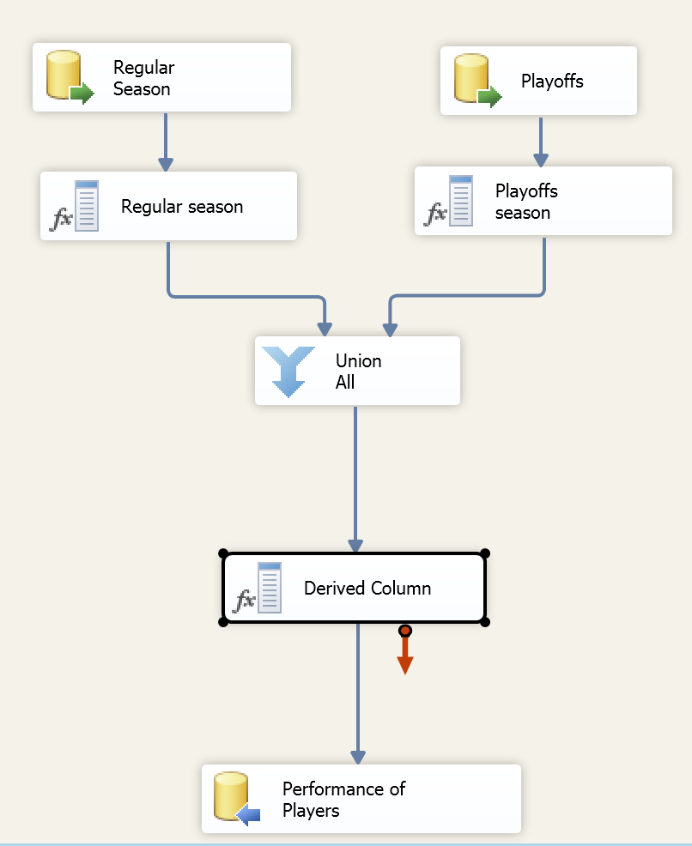 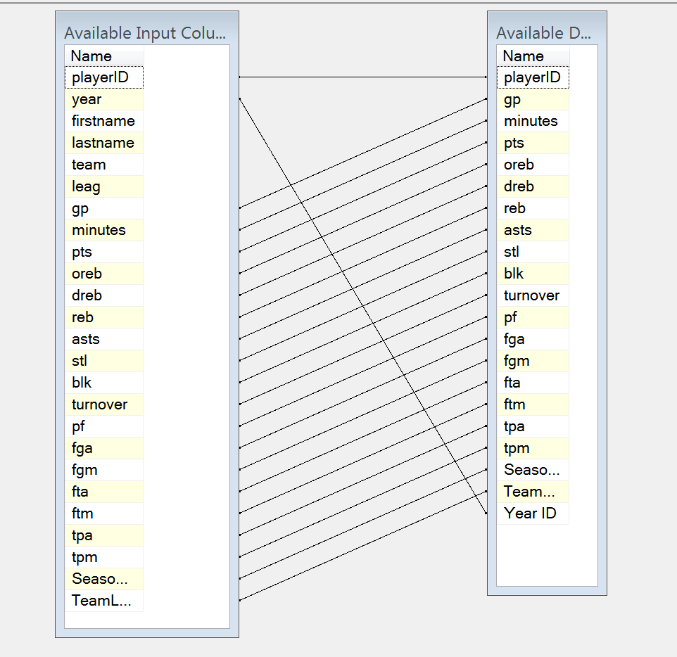

The problem in this step is that {team: TOT} and {team: SL1} are missing in the [Teams_State] table. And {team: MIN, leag: F} is wrong which ‘leag’ should be ‘N’.

Finally, the constellation schema has shown in following picture

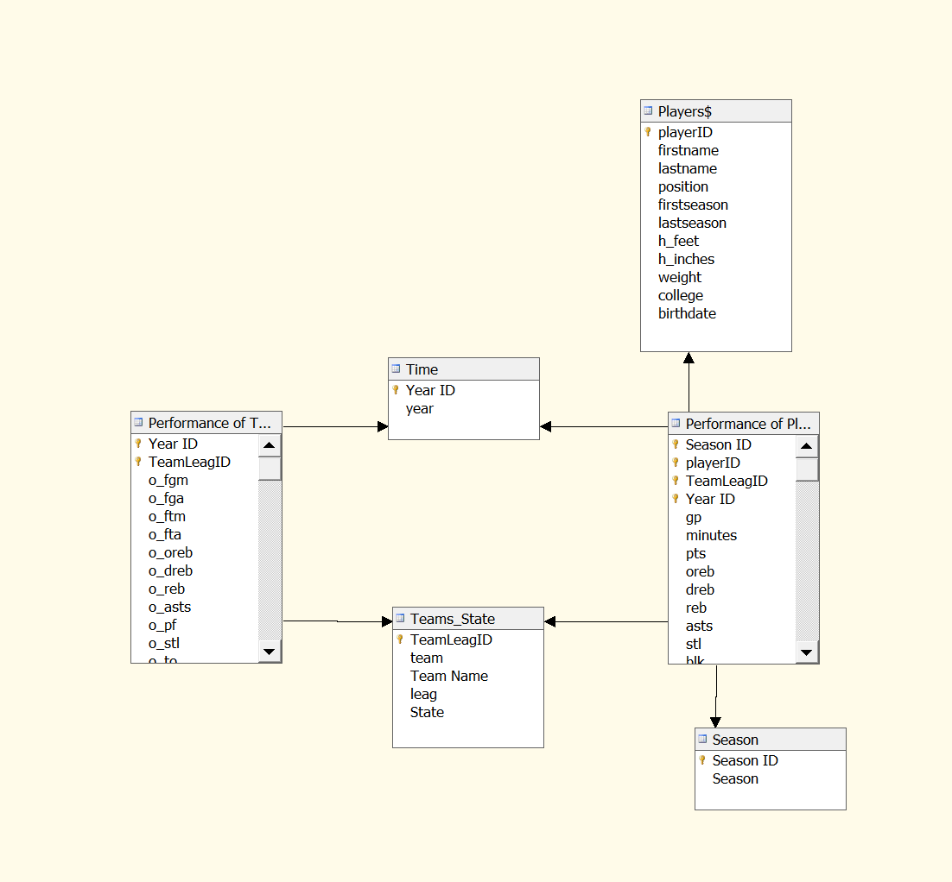

Fact table:

Performance of Teams(playerID, Year ID, Season ID, TeamLeagID, gp, minutes, pts, oreb, dreb, reb, asts, stl, blk, turnover, pf, fga, fgm, fta, ftm, tpa, tpm)

Performance of Players(Year ID, TeamLeagID ,o_fgm, o_fga, o_ftm, o_fta, o_oreb, o_dreb, o_reb, o_asts, o_pf, o_stl, o_to, o_blk, o_3pm, o_3pa, o_pts, d_fgm, d_fga, d_ftm, d_fta, d_oreb, d_dreb, d_reb, d_asts, d_pf, d_stl, d_to, d_blk, d_3pm, d_3pa, d_pts, pace, won, lost)

Dimension table:

Players(playerID, firstname, lastname, position, firstseason, lastseason, h_feet, h_inches, weight, college, birthdate)

Teams_State(TeamLeagID, team, Team Name, leag, State)

Time(Year ID, year)

Season(SeasonID, season)

# Task 2

Cube

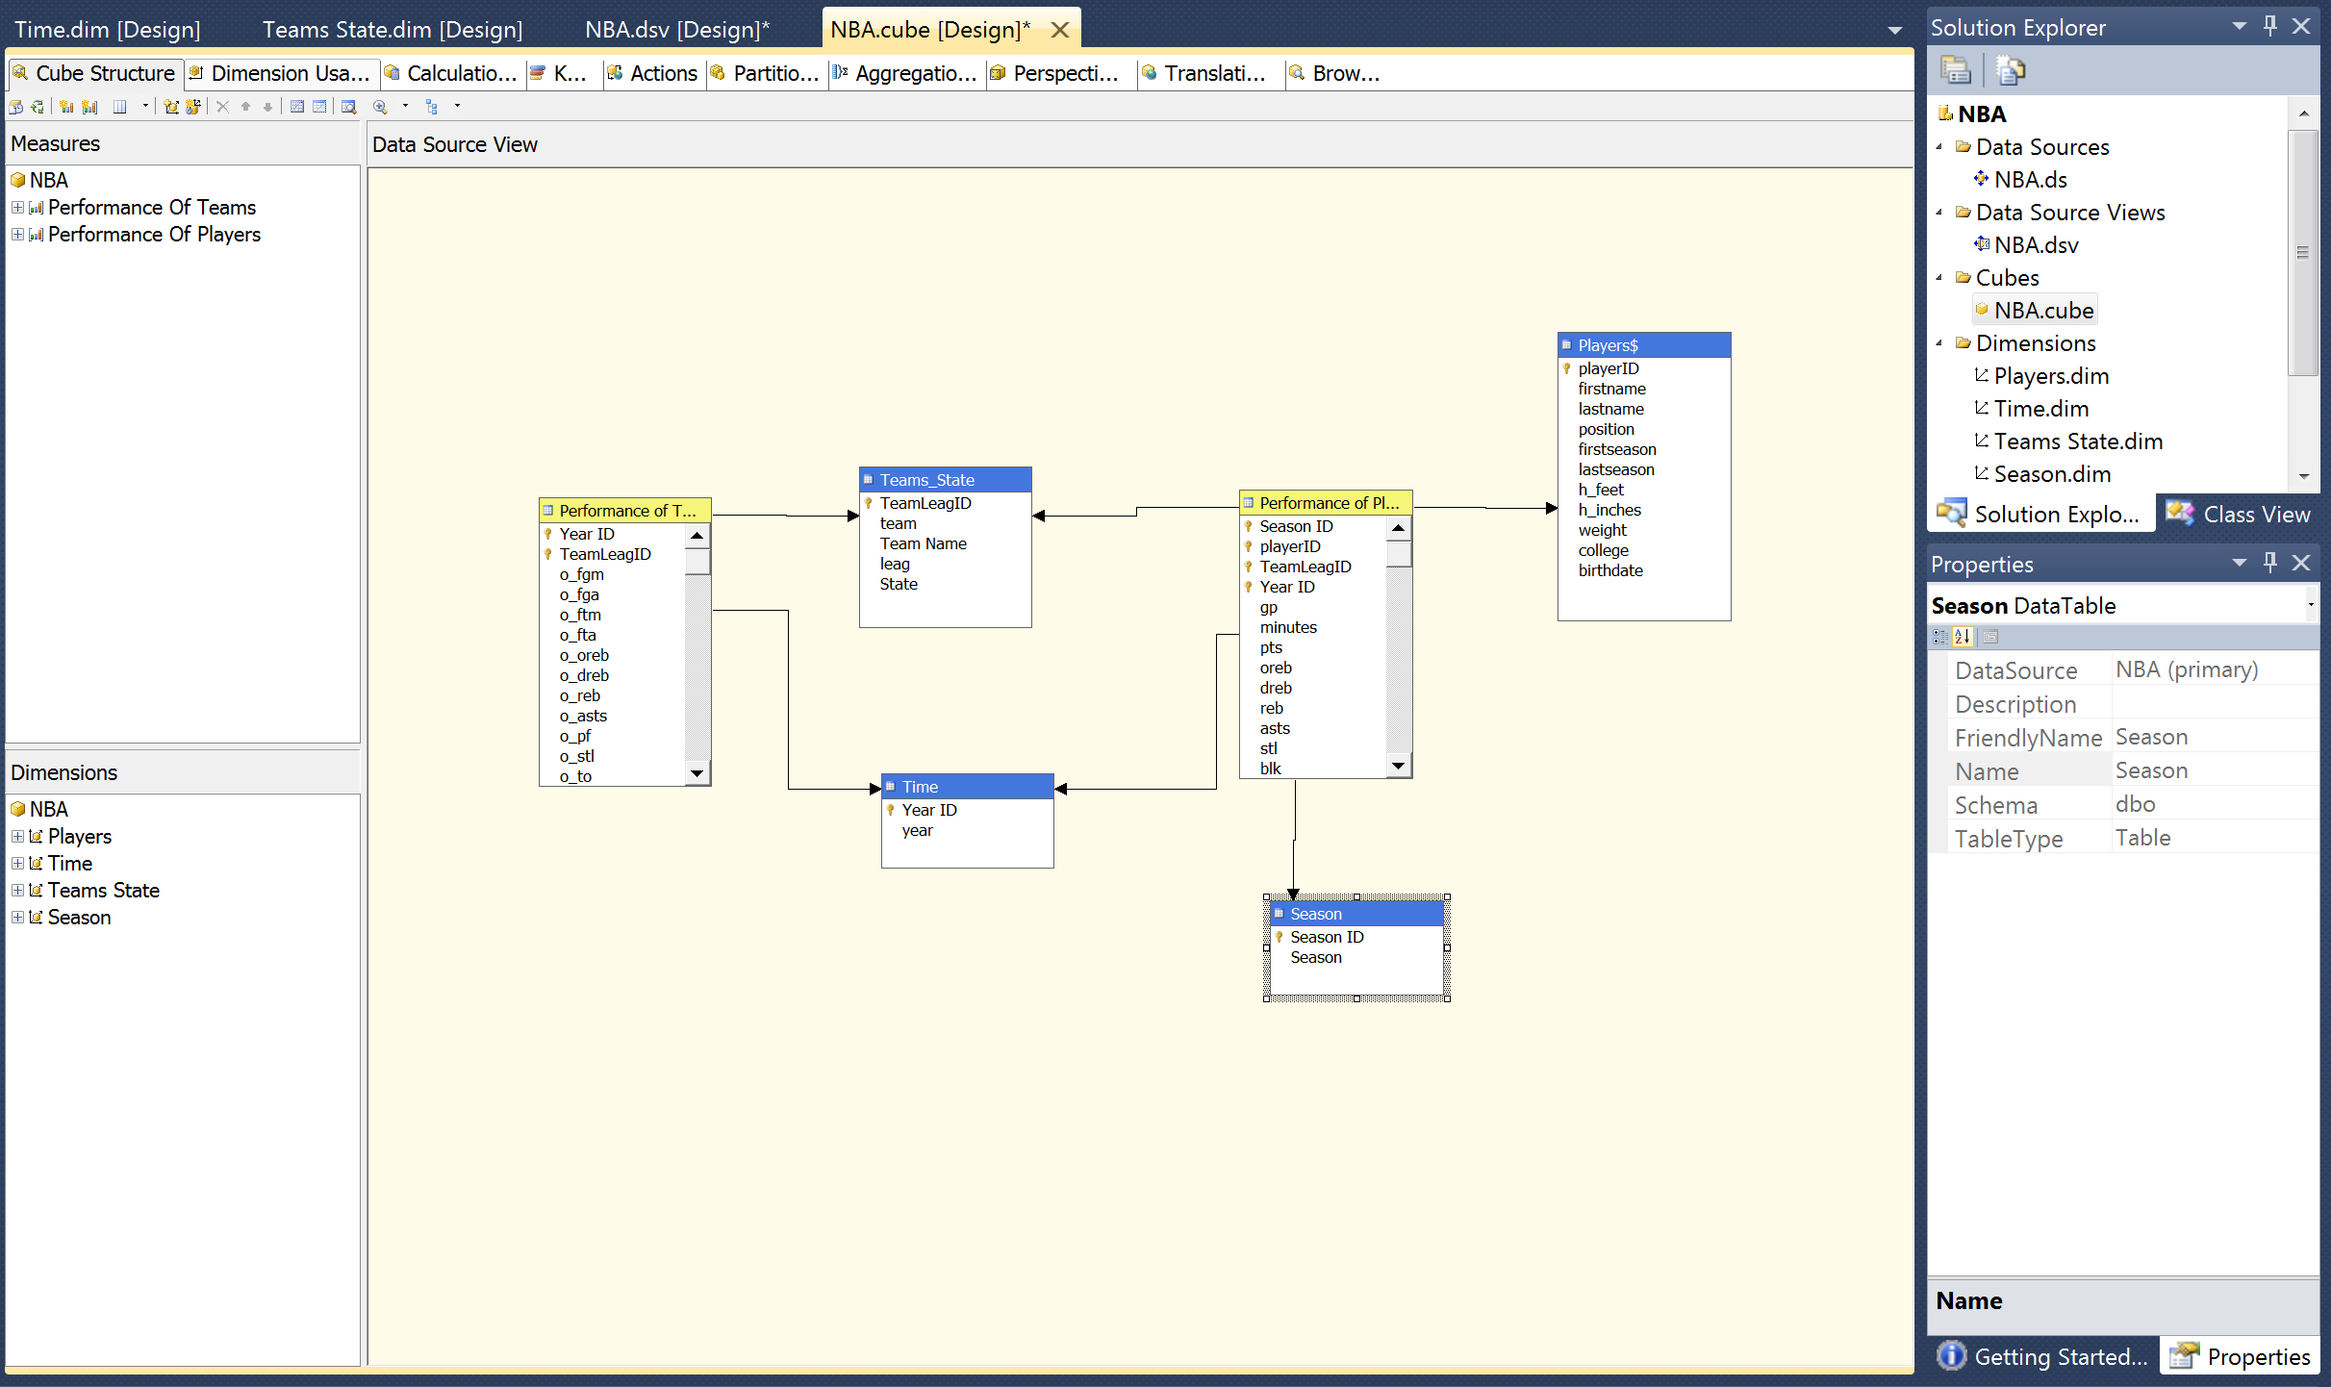

Dimension

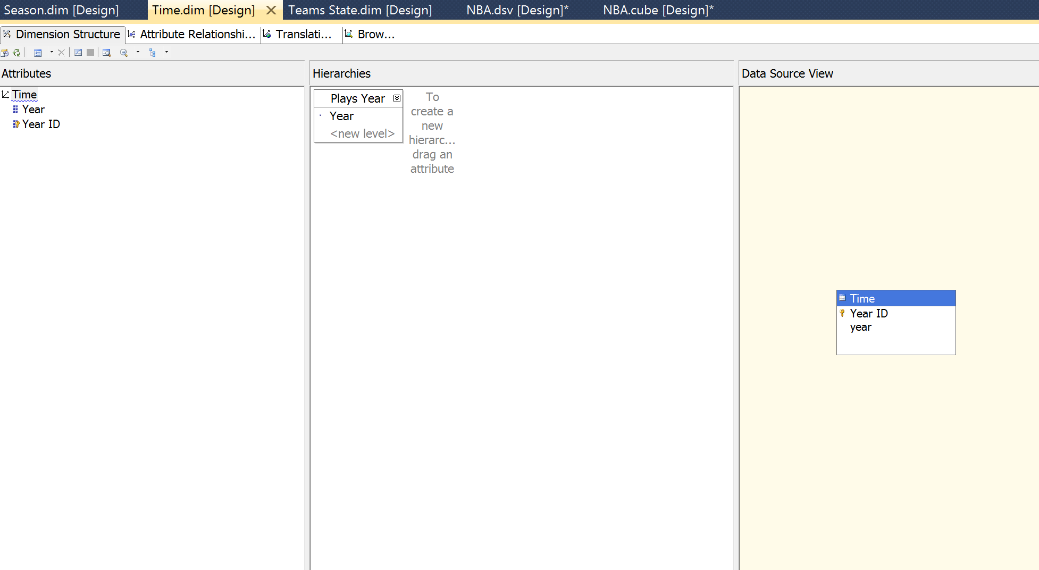

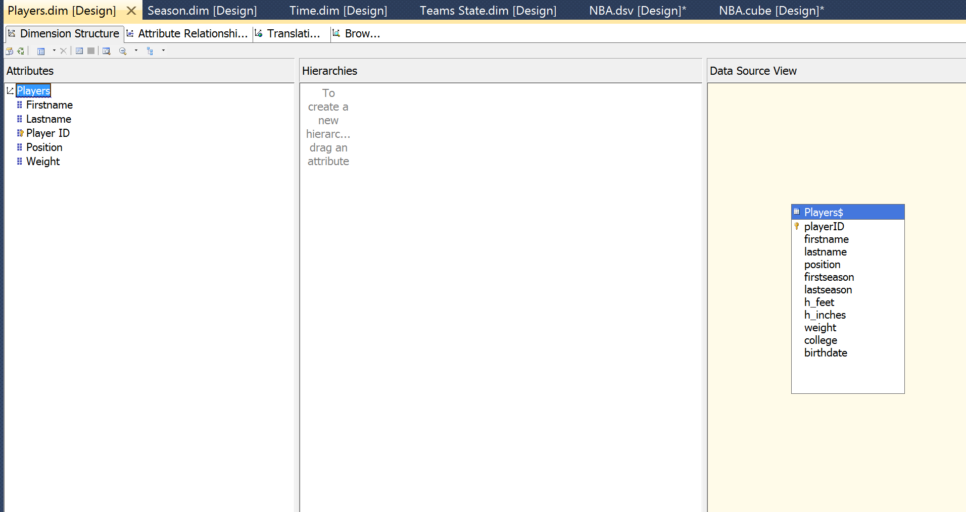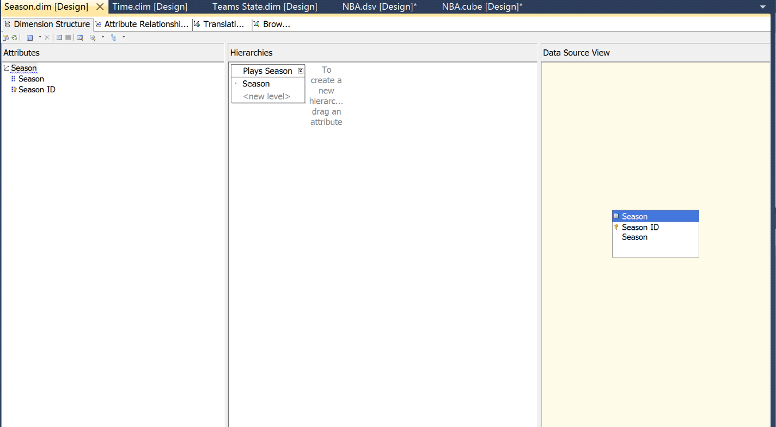  
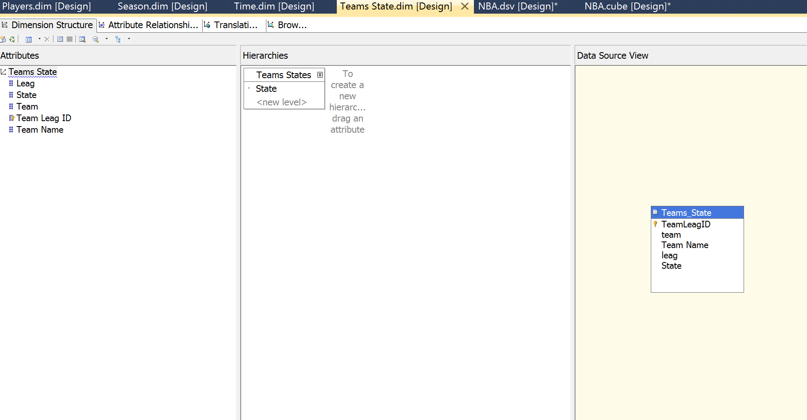

# TASK3

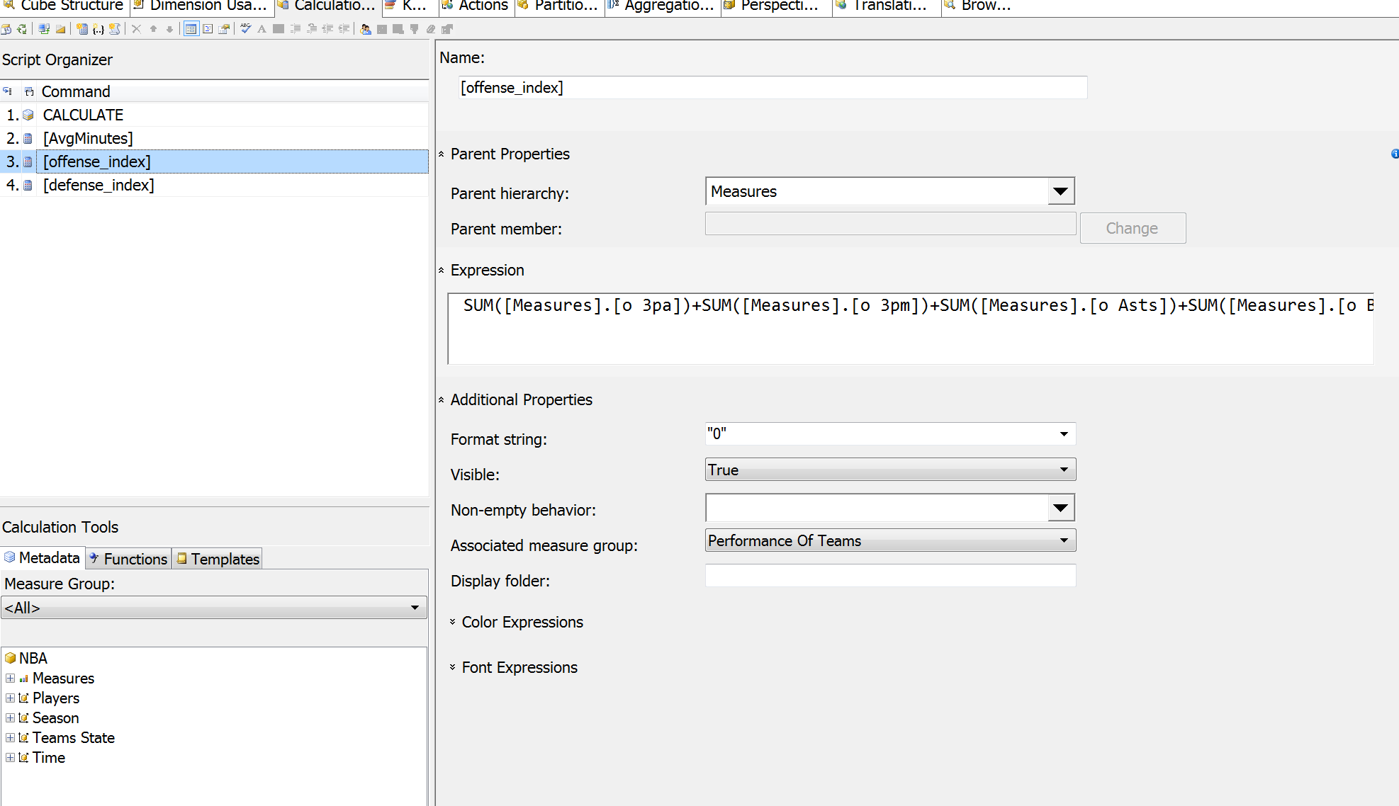

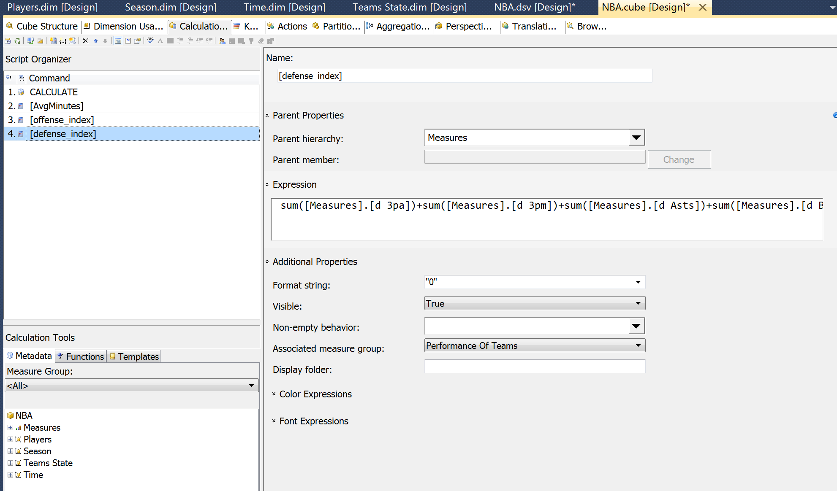

Q1:

SELECT NON EMPTY { [Measures].[offense_index], [Measures].[defense_index] } ON COLUMNS, NON EMPTY { ([Teams State].[Team Name].[Team Name].ALLMEMBERS ) } DIMENSION PROPERTIES MEMBER_CAPTION, MEMBER_UNIQUE_NAME ON ROWS FROM ( SELECT ( { [Teams State].[Team Name].&[Chicago Stags], [Teams State].[Team Name].&[Floridians], [Teams State].[Team Name].&[Orlando Magic] } ) ON COLUMNS FROM [NBA]) CELL PROPERTIES VALUE, BACK_COLOR, FORE_COLOR, FORMATTED_VALUE, FORMAT_STRING, FONT_NAME, FONT_SIZE, FONT_FLAGS

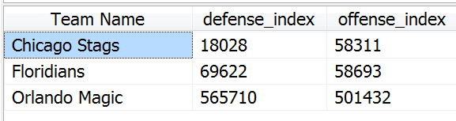 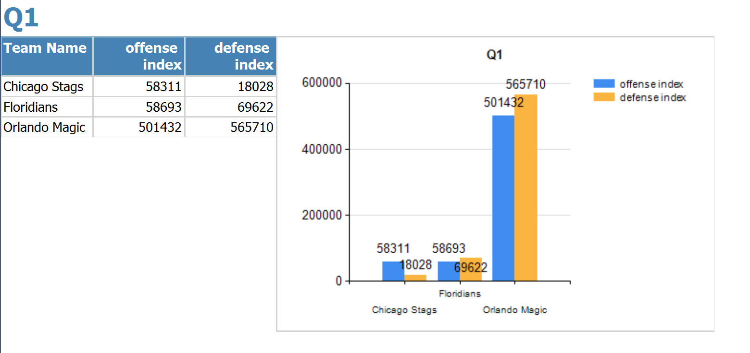

Q2:

SELECT NON EMPTY { [Measures].[Won], [Measures].[Lost] } ON COLUMNS, NON EMPTY { ([Teams State].[Team].[Team].ALLMEMBERS * [Teams State].[Team Name].[Team Name].ALLMEMBERS ) } DIMENSION PROPERTIES MEMBER_CAPTION, MEMBER_UNIQUE_NAME ON ROWS FROM ( SELECT ( { [Teams State].[State].&[Florida] } ) ON COLUMNS FROM [NBA]) WHERE ( [Teams State].[State].&[Florida] ) CELL PROPERTIES VALUE, BACK_COLOR, FORE_COLOR, FORMATTED_VALUE, FORMAT_STRING, FONT_NAME, FONT_SIZE, FONT_FLAGS

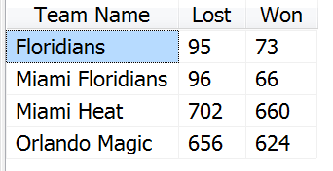

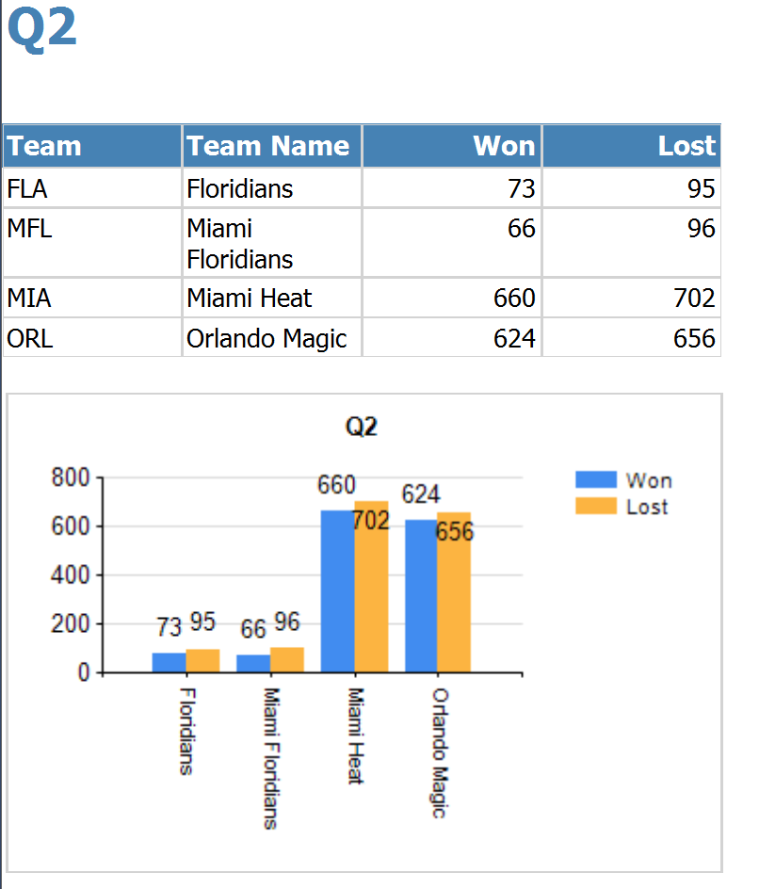

Q3:

SELECT NON EMPTY { [Measures].[offense_index] } ON COLUMNS, NON EMPTY TOPCOUNT({ ([Teams State].[Team].[Team].ALLMEMBERS * [Teams State].[Team Name].[Team Name].ALLMEMBERS ) } ,10,[Measures].[offense_index] )DIMENSION PROPERTIES MEMBER_CAPTION, MEMBER_UNIQUE_NAME ON ROWS FROM [NBA] CELL PROPERTIES VALUE, BACK_COLOR, FORE_COLOR, FORMATTED_VALUE, FORMAT_STRING, FONT_NAME, FONT_SIZE, FONT_FLAGS

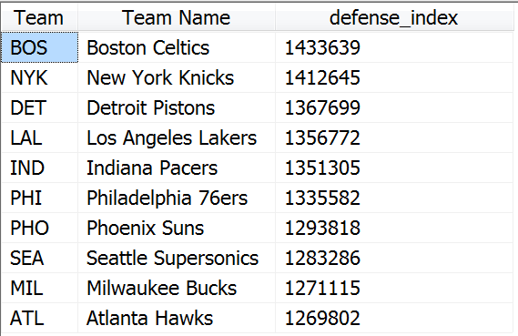

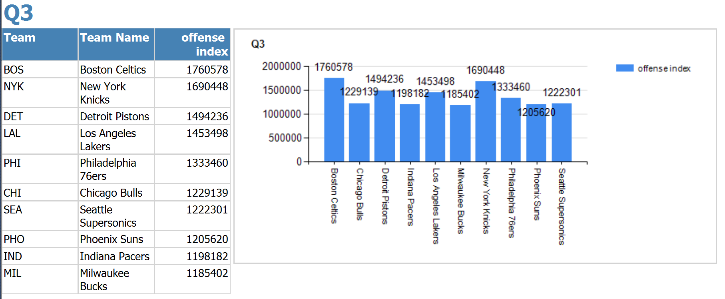

Q4:

SELECT NON EMPTY { [Measures].[defense_index] } ON COLUMNS,

NON EMPTY Order(Filter(

{ ([Teams State].[Team].[Team].ALLMEMBERS * [Teams State].[Team Name].[Team Name].ALLMEMBERS ) }

, [Measures].[defense_index]>1300000 ), [Measures].[defense_index] ,BDESC)

DIMENSION PROPERTIES MEMBER_CAPTION, MEMBER_UNIQUE_NAME ON ROWS FROM [NBA] CELL PROPERTIES VALUE, BACK_COLOR, FORE_COLOR, FORMATTED_VALUE, FORMAT_STRING, FONT_NAME, FONT_SIZE, FONT_FLAGS

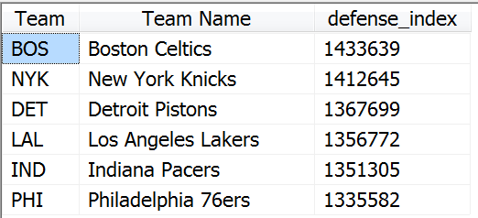

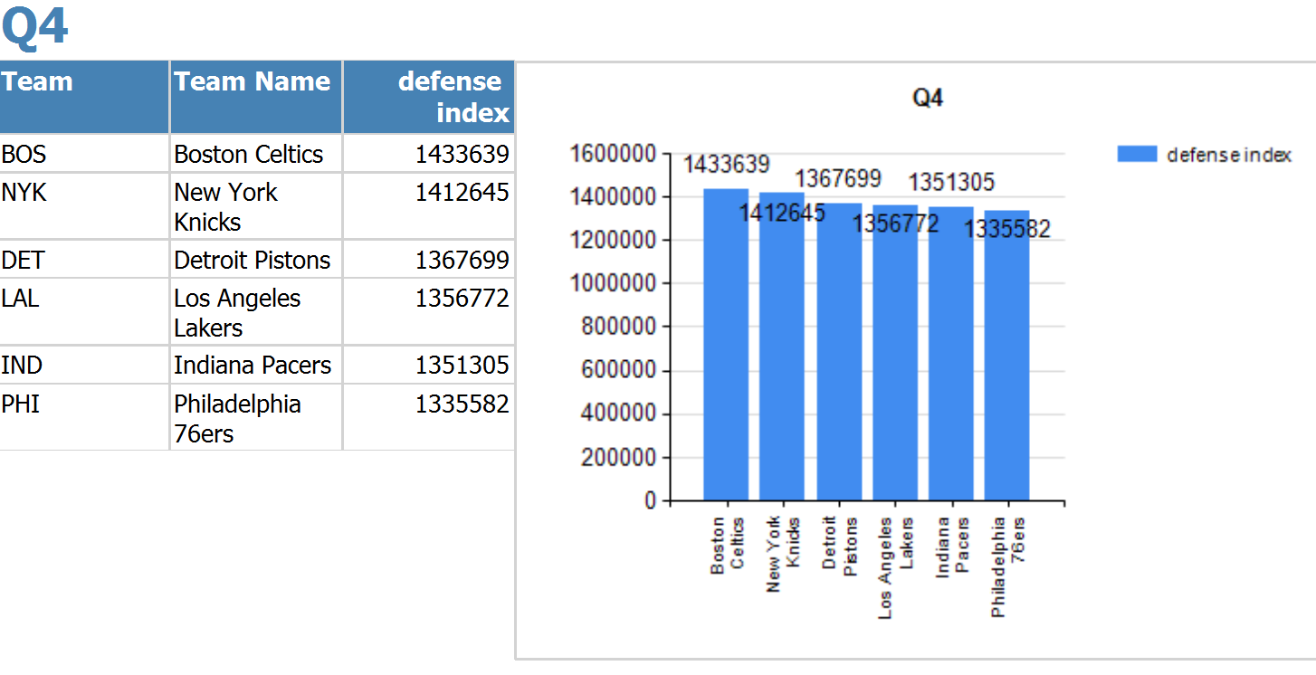

Q5:

SELECT NON EMPTY { [Measures].[Pts] } ON COLUMNS, NON EMPTY TOPCOUNT( { ([Players].[Firstname].[Firstname].ALLMEMBERS * [Players].[Lastname].[Lastname].ALLMEMBERS ) } ,5,[Measures].[Pts] )DIMENSION PROPERTIES MEMBER_CAPTION, MEMBER_UNIQUE_NAME ON ROWS FROM ( SELECT ( [Players].[Weight].&[1.35E2] : [Players].[Weight].&[1.5E2] ) ON COLUMNS FROM ( SELECT ( { [Season].[Plays Season].[Season].&[Playoffs] } ) ON COLUMNS FROM [NBA])) WHERE ( [Season].[Plays Season].[Season].&[Playoffs] ) CELL PROPERTIES VALUE, BACK_COLOR, FORE_COLOR, FORMATTED_VALUE, FORMAT_STRING, FONT_NAME, FONT_SIZE, FONT_FLAGS

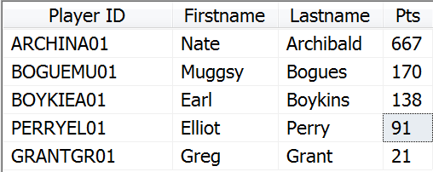

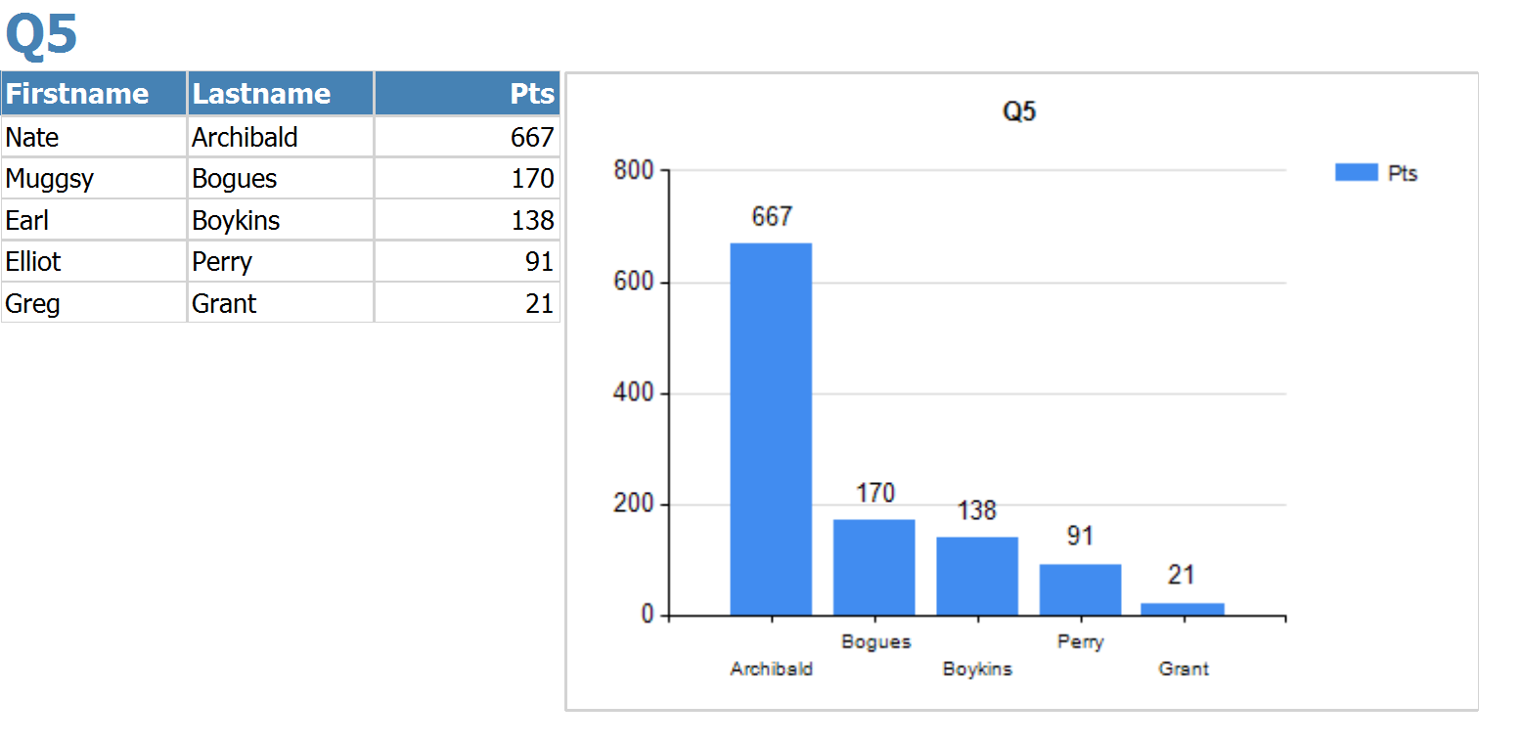

Q6:

SELECT NON EMPTY { [Measures].[WON], [Measures].[Lost] } ON COLUMNS,

NON EMPTY {

([Teams State].[Team].&[BOS],[Time].[Year].&[1.950E3]),

([Teams State].[Team].&[NYK],[Time].[Year].&[1.951E3])

}ON ROWS FROM [NBA] CELL PROPERTIES VALUE, BACK_COLOR, FORE_COLOR, FORMATTED_VALUE, FORMAT_STRING, FONT_NAME, FONT_SIZE, FONT_FLAGS

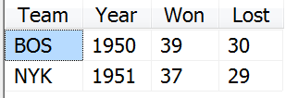

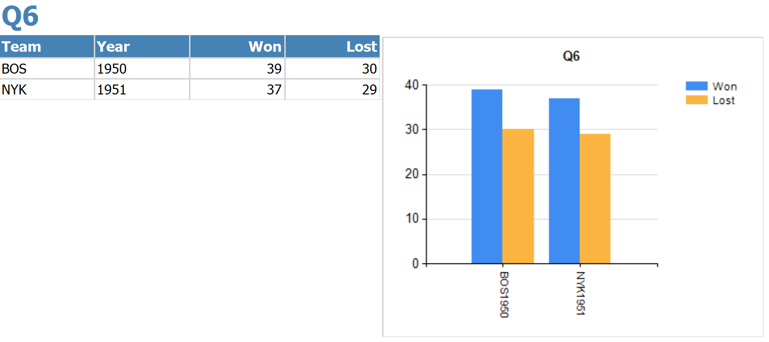

Q7:

SELECT NON EMPTY { [Measures].[defense_index] } ON COLUMNS,

NON EMPTYBOTTOMCOUNT({ ([Teams State].[Team Name].[Team Name].ALLMEMBERS ) } ,6, [Measures].[defense_index])DIMENSION PROPERTIES MEMBER_CAPTION, MEMBER_UNIQUE_NAME ON ROWS FROM [NBA] CELL PROPERTIES VALUE, BACK_COLOR, FORE_COLOR, FORMATTED_VALUE, FORMAT_STRING, FONT_NAME, FONT_SIZE, FONT_FLAGS

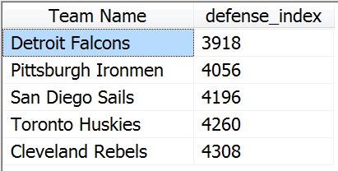

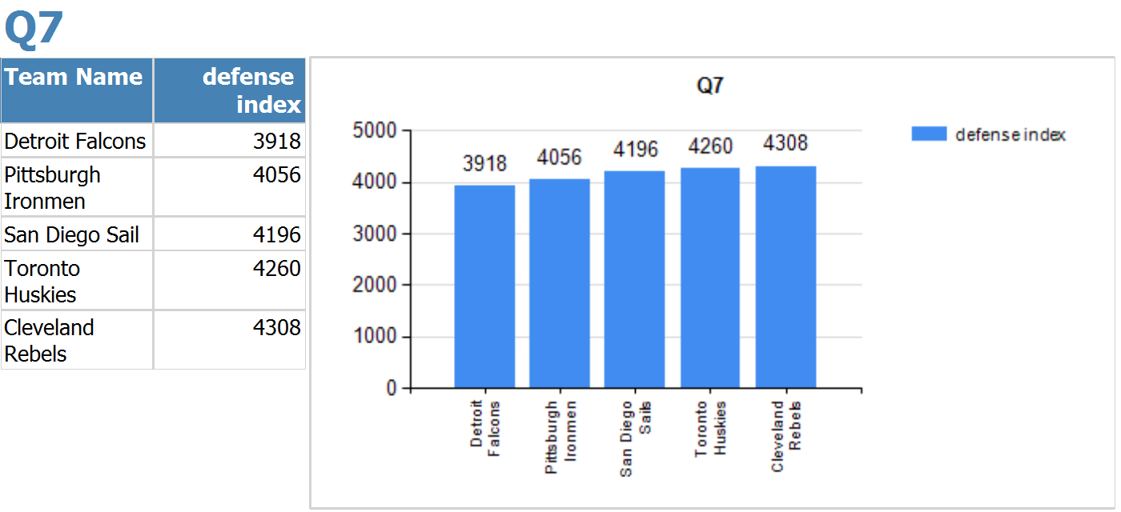

Q8:

SELECT NON EMPTY { [Measures].[Lost], [Measures].[Won] } ON COLUMNS, NON EMPTY { ([Teams State].[Team Name].[Team Name].ALLMEMBERS ) } DIMENSION PROPERTIES MEMBER_CAPTION, MEMBER_UNIQUE_NAME ON ROWS FROM ( SELECT ( [Time].[Year].&[1.95E3] : [Time].[Year].&[1.952E3] ) ON COLUMNS FROM [NBA]) CELL PROPERTIES VALUE, BACK_COLOR, FORE_COLOR, FORMATTED_VALUE, FORMAT_STRING, FONT_NAME, FONT_SIZE, FONT_FLAGS

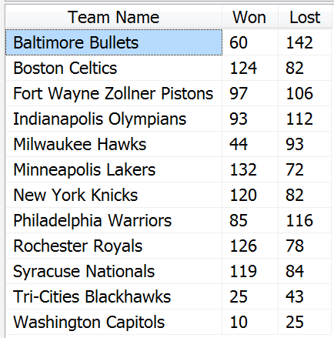

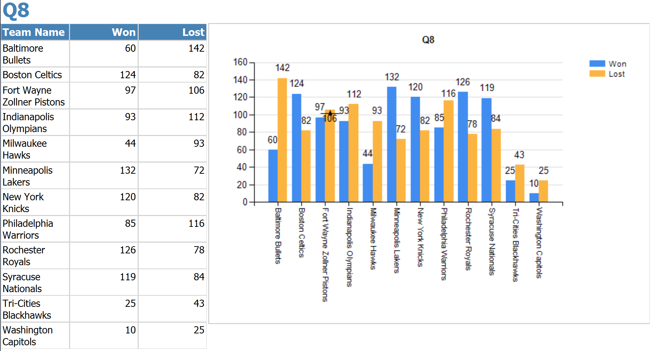

Q9:

SELECT NON EMPTY { [Measures].[Lost] } ON COLUMNS, NON EMPTY ORDER( CROSSJOIN({ [Teams State].[Team].[Team].ALLMEMBERS} , {[Time].[Plays Year].[Year].ALLMEMBERS }) ,[Measures].[Lost] ,BDESC) DIMENSION PROPERTIES MEMBER_CAPTION, MEMBER_UNIQUE_NAME ON ROWS FROM ( SELECT ( [Time].[Year].&[1.951E3] : [Time].[Year].&[1.952E3] ) ON COLUMNS FROM [NBA]) CELL PROPERTIES VALUE, BACK_COLOR, FORE_COLOR, FORMATTED_VALUE, FORMAT_STRING, FONT_NAME, FONT_SIZE, FONT_FLAGS

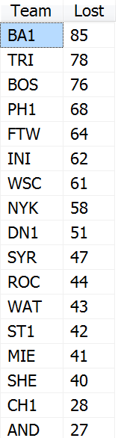

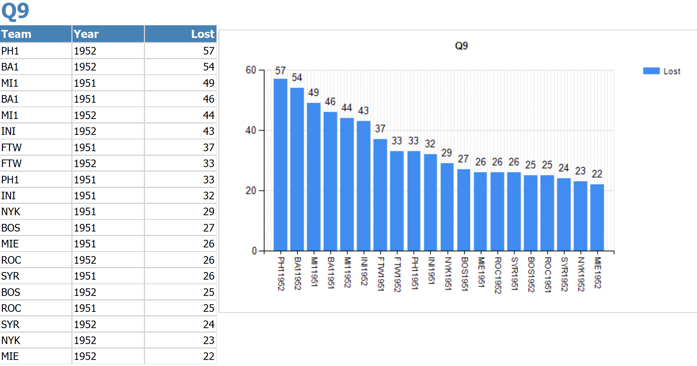

Q10:

WITH MEMBER [Measures].[Top offense_index] AS { EXISTING TopCount([Teams State].[Team].[Team].ALLMEMBERS,1, ([Measures].[offense_index]) ) *{[Measures].[offense_index]}}.Item(0) SELECT NON EMPTY { [Measures].[Top offense_index] } ON COLUMNS, NON EMPTY { ([Time].[Year].[Year],[Teams State].[Team].[Team].ALLMEMBERS ) } DIMENSION PROPERTIES MEMBER_CAPTION, MEMBER_UNIQUE_NAME ON ROWS FROM [NBA] CELL PROPERTIES VALUE, BACK_COLOR, FORE_COLOR, FORMATTED_VALUE, FORMAT_STRING, FONT_NAME, FONT_SIZE, FONT_FLAGS

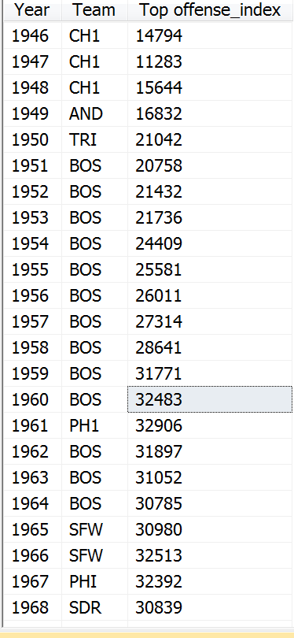

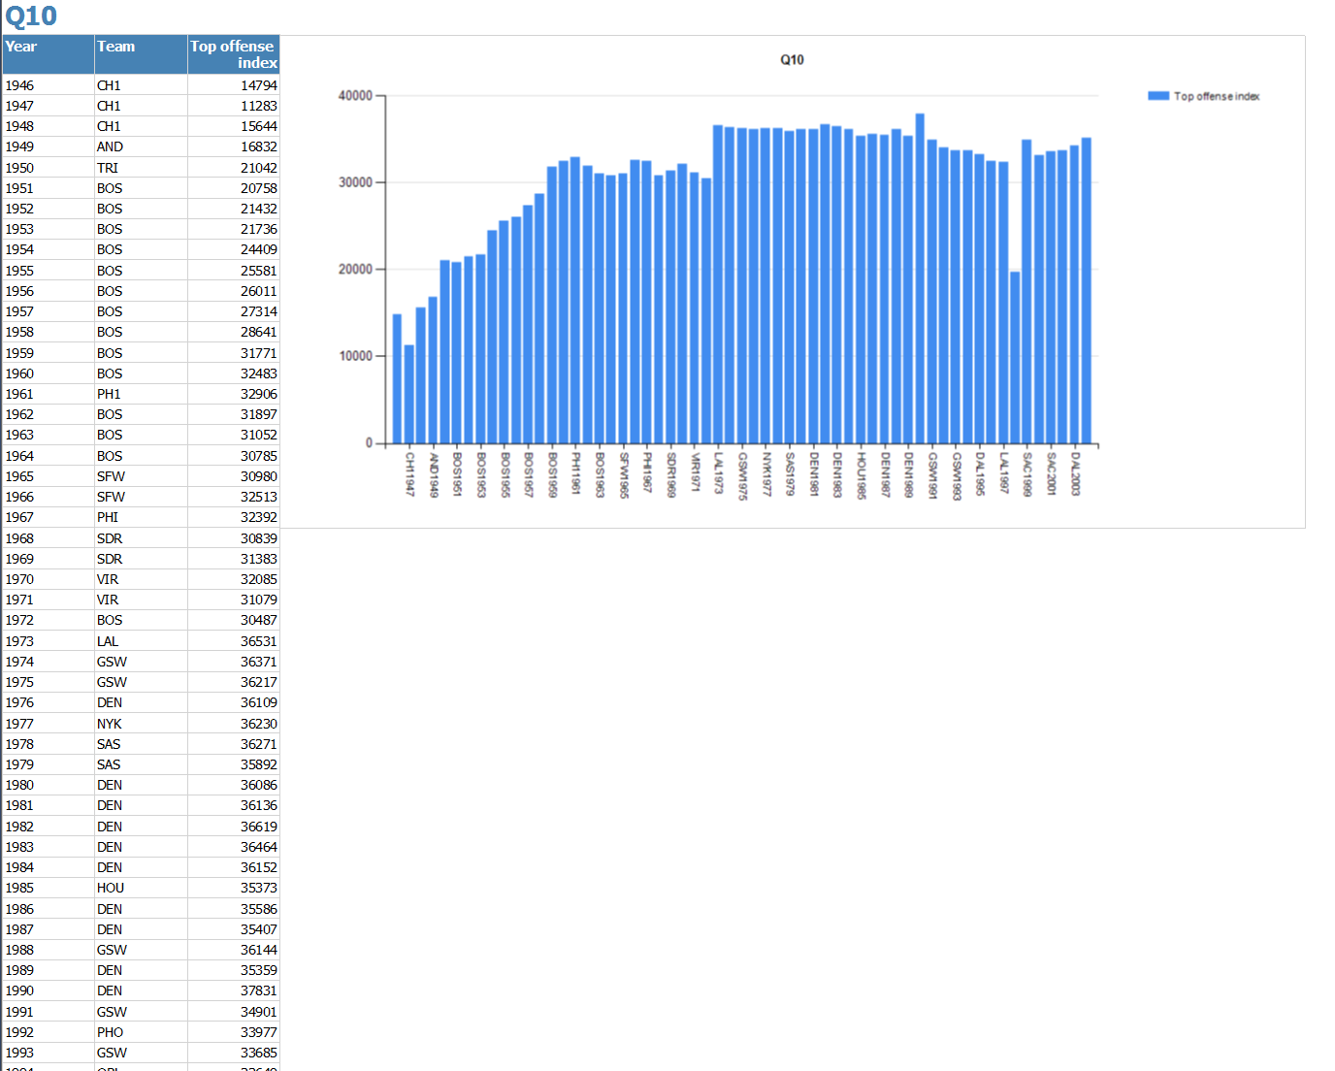

Q11:

SELECT NON EMPTY { [Measures].[Turnover] } ON COLUMNS,NON EMPTY TOPCOUNT ( Filter( { ([Players].[Player ID].[Player ID].ALLMEMBERS * [Players].[Firstname].[Firstname].ALLMEMBERS * [Players].[Lastname].[Lastname].ALLMEMBERS ) } , [Measures].[Turnover] > 300), 10,[Measures].[Turnover]) ON ROWS FROM ( SELECT ( { [Season].[Season].&[Playoffs] } ) ON COLUMNS FROM ( SELECT ( { [Players].[Position].&[G] } ) ON COLUMNS FROM [NBA])) WHERE ( [Players].[Position].&[G], [Season].[Season].&[Playoffs] ) CELL PROPERTIES VALUE, BACK_COLOR, FORE_COLOR, FORMATTED_VALUE, FORMAT_STRING, FONT_NAME, FONT_SIZE, FONT_FLAGS

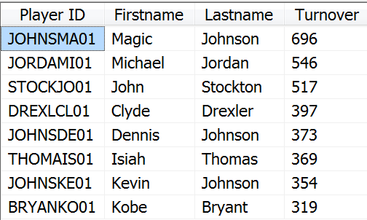

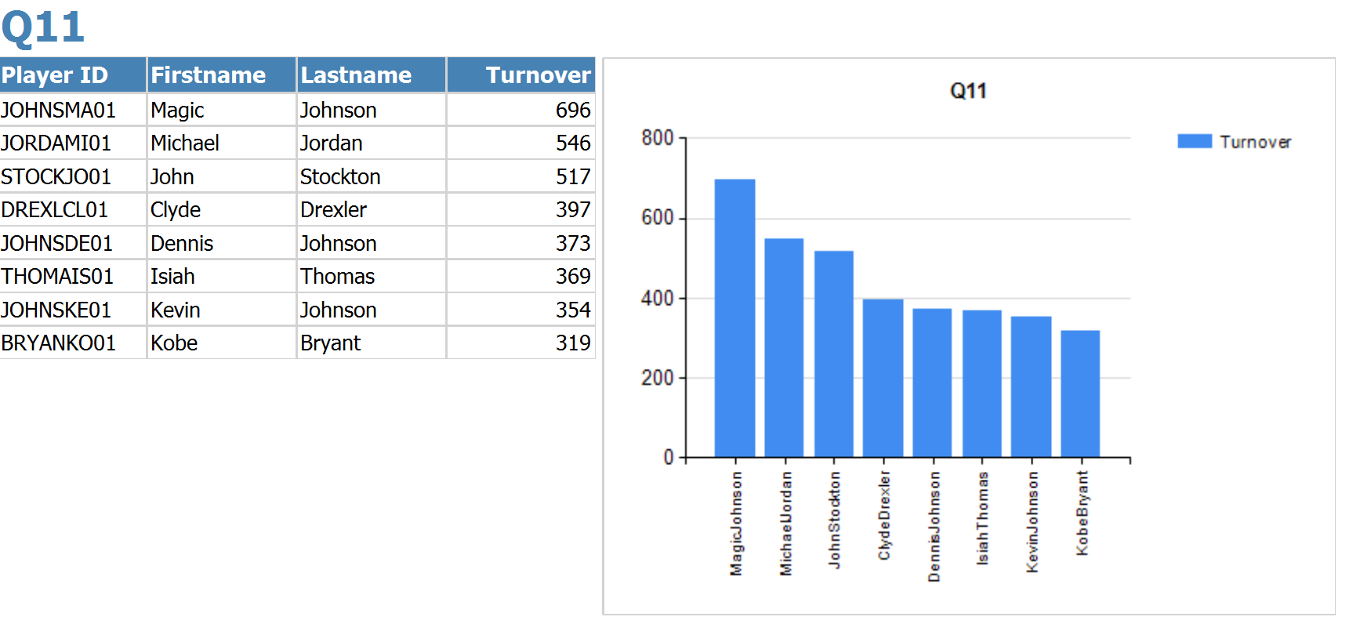

Q12:

SELECT NON EMPTY { [Measures].[Minutes] } ON COLUMNS, NON EMPTY TOPCOUNT ({ ([Players].[Player ID].[Player ID].ALLMEMBERS ) } ,5,[Measures].[Minutes])DIMENSION PROPERTIES MEMBER_CAPTION, MEMBER_UNIQUE_NAME ON ROWS FROM ( SELECT ( { [Players].[Position].&[F] } ) ON COLUMNS FROM ( SELECT ( { [Season].[Plays Season].[Season].&[Regular Season] } ) ON COLUMNS FROM [NBA])) WHERE ( [Season].[Plays Season].[Season].&[Regular Season], [Players].[Position].&[F] ) CELL PROPERTIES VALUE, BACK_COLOR, FORE_COLOR, FORMATTED_VALUE, FORMAT_STRING, FONT_NAME, FONT_SIZE, FONT_FLAGS

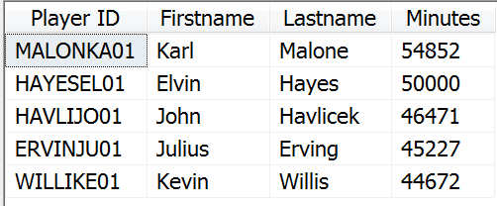

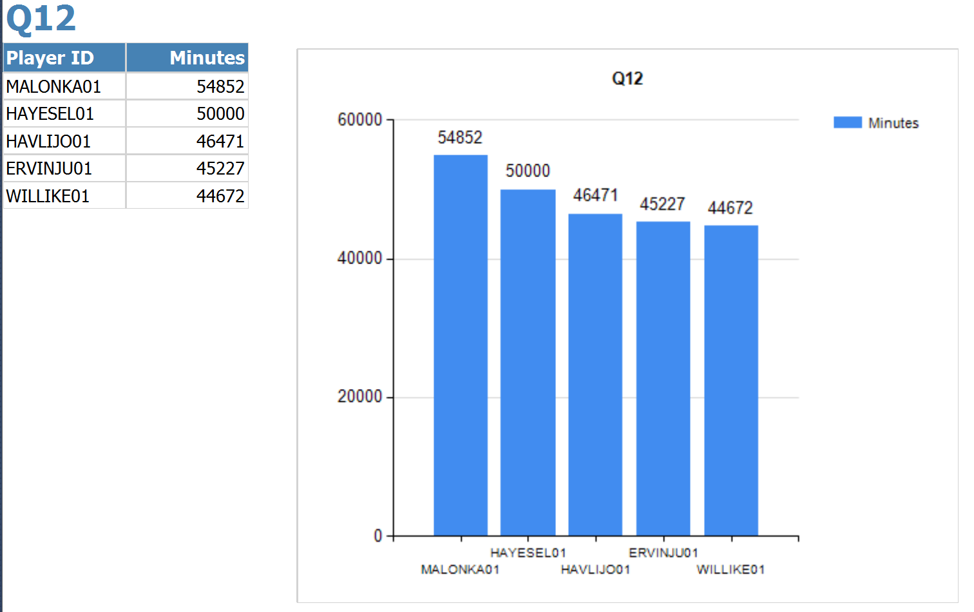

Q13:

WITH MEMBER [Measures].[AvgMinutes] AS '([Season].[Season].&[Playoffs], Measures.Minutes)/SUM( [Season].[Season].&[Playoffs],[Measures].[Performance Of Players Count] )', FORMAT_STRING='0.0'SELECT NON EMPTY { [Measures].[AvgMinutes] } ON COLUMNS, NON EMPTY { ([Players].[Position].[Position].ALLMEMBERS ) } DIMENSION PROPERTIES MEMBER_CAPTION, MEMBER_UNIQUE_NAME ON ROWS FROM [NBA] CELL PROPERTIES VALUE, BACK_COLOR, FORE_COLOR, FORMATTED_VALUE, FORMAT_STRING, FONT_NAME, FONT_SIZE, FONT_FLAGS

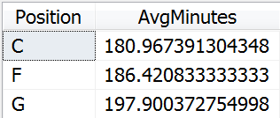

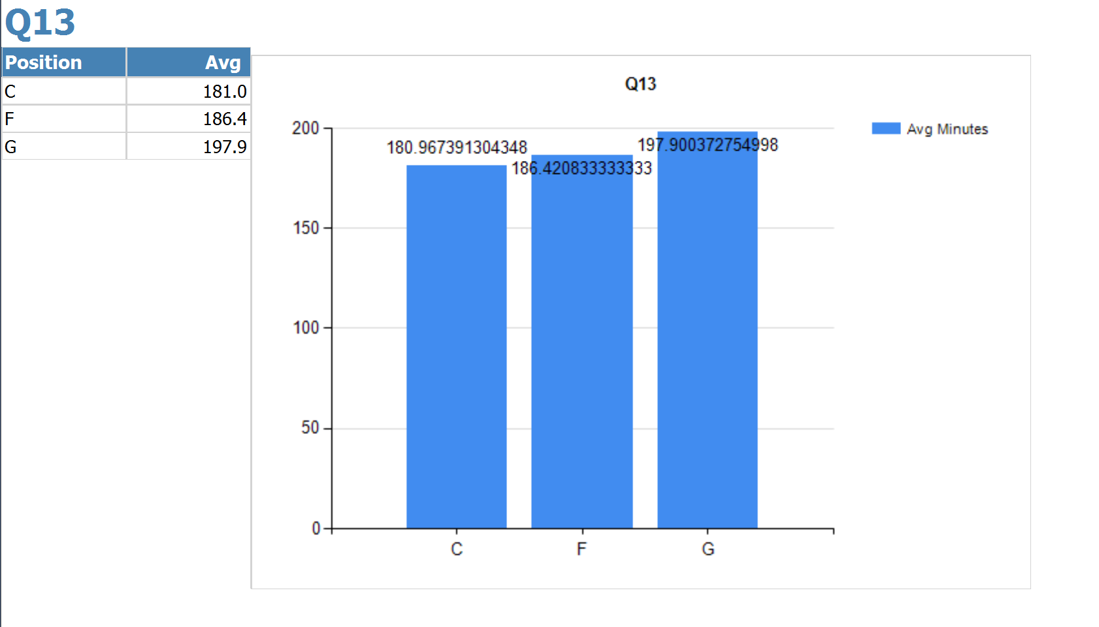

Q14:

WITH

MEMBER [offense_index 1951] AS ([Measures].[offense_index], [Time].[Year].&[1.952E3].prevMember)

MEMBER [offense_index 1952] AS ([Measures].[offense_index], [Time].[Year].&[1.952E3])

MEMBER [offense_index difference] AS ([Measures].[offense_index], [Time].[Year].&[1.952E3])-([Measures].[offense_index], [Time].[Year].&[1.952E3].prevMember)

SELECT NON EMPTY { [Measures].[offense_index 1951], [Measures].[offense_index 1952], [Measures].[offense_index difference] } ON COLUMNS, NON EMPTY { ([Teams State].[Team].[Team].ALLMEMBERS ) } DIMENSION PROPERTIES MEMBER_CAPTION, MEMBER_UNIQUE_NAME ON ROWS FROM [NBA] CELL PROPERTIES VALUE, BACK_COLOR, FORE_COLOR, FORMATTED_VALUE, FORMAT_STRING, FONT_NAME, FONT_SIZE, FONT_FLAGS

